**Roll no.: 2 -** until 2-3 roll nos the instructions for keeping the camera on wasn’t passed, but ig after that all will have to keep their camera on, the external asked regarding:

1) What are CRUD operations? Tell me the full form of CRUD.

As we know that we can use MongoDB for various things like building an application (including web and mobile), or analysis of data, or an administrator of a MongoDB database, in all these cases we need to interact with the MongoDB server to perform certain operations like entering new data into the application, updating data into the application, deleting data from the application, and reading the data of the application.

MongoDB provides a set of some basic but most essential operations that will help you to easily interact with the MongoDB server and these operations are known as **CRUD operations**.

**Create Operations –**

The create or insert operations are used to insert or add new documents in the collection. If a collection does not exist, then it will create a new collection in the database. You can perform, create operations using the following methods provided by the MongoDB:

|  |  |
| --- | --- |
| **METHOD** | **DESCRIPTION** |
| **db.collection.insertOne()** | It is used to insert a single document in the collection. |
| **db.collection.insertMany()** | It is used to insert multiple documents in the collection. |

## Read Operations –

The Read operations are used to retrieve documents from the collection, or in other words, read operations are used to query a collection for a document. You can perform read operation using the following method provided by the MongoDB:

|  |  |
| --- | --- |
| **METHOD** | **DESCRIPTION** |
| **db.collection.find()** | It is used to retrieve documents from the collection. |

**Update Operations –**

The update operations are used to update or modify the existing document in the collection. You can perform update operations using the following methods provided by the MongoDB:

|  |  |
| --- | --- |
| **METHOD** | **DESCRIPTION** |
| **db.collection.updateOne()** | It is used to update a single document in the collection that satisfy the given criteria. |
| **db.collection.updateMany()** | It is used to update multiple documents in the collection that satisfy the given criteria. |
| **db.collection.replaceOne()** | It is used to replace single document in the collection that satisfy the given criteria. |

**Delete Operations –**

The delete operation are used to delete or remove the documents from a collection. You can perform delete operations using the following methods provided by the MongoDB:

|  |  |
| --- | --- |
| **METHOD** | **DESCRIPTION** |
| **db.collection.deleteOne()** | It is used to delete a single document from the collection that satisfy the given criteria. |
| **db.collection.deleteMany()** | It is used to delete multiple documents from the collection that satisfy the given criteria. |

2) what are the 5 elements of UX? Tell

me about the first 2 elements of UX and how they’re related.

## Strategy

The reason for the product, application or the site, why we create it, who are we doing this for, why people are willing to use it, why they need it. The goal here is to define the user needs and business objectives.

I create this prototype for passenger those who want to book taxi as well as can search taxi nearby their location so they can select type of taxi and taxi driver experience also.

This could be done through **Strategic Research Process**, where you interview users, and all stakeholders in addition to review the competing products or companies.

## Scope

Defines the functional and content requirements. What are the features, and content contained in the application. The requirements should fulfill and be aligned with the strategic goals.

Functional Requirements It’s the requirements about the functions, or features in the product, how features work with each other, and how they interrelate with each other. These features are what user need to reach the objectives.

Content Requirements It’s the information we need in order to provide the value. Information like text, images, audio, videos, …etc. Without defining the content, we have no idea about the size or time required to complete the project.

**Scope:**

* **Function Requirements:**
* Tracking Realtime
* Login with number
* OTP verification
* Search Taxi
* **Content Requirements:**
* Phone No
* Source & Destination
* Review

## Structure

Defines how user interact with the product, how system behave when user interact, how it’s organized, prioritized, and how much of it. Structure is split into two components, Interaction Design & Information Architecture.

Interaction Design Given the functional requirements, It defines how user can interact with the product, and how the system behaves in response to the user interactions.

* In this application user need to enter phone no to book taxi after that OTP will send to user and verification take place. Also, when user enter source and destination after that system give response that select which type of taxi you want.
* Information Architecture Given the content requirements, It defines the arrangement of content elements, how they are organized, to facilitate human understanding.

## Skeleton

Skeleton determines the visual form on the screen, presentation and arrangement of all elements that makes us interact with the functionality of the system that exist on the interface. Also how the user moves through the information, and how information is presented to make it effective, clear, obvious.

**Wireframes** are widely used to create a visual format, which is a Static diagram that represent a visual format of the product, including content, navigation and ways for interactions.

Skeleton is split into three components Interface Design, Navigation Design, & Information Design.

* Interface Design presenting and arranging interface elements to enable users to interact with the functionality of the system.
* Navigation Design how to navigate through the information using the interface.
* Information Design defines the presentation of information in a way that facilitates understanding.

## Surface

It’s the sum total of all the work and decisions we have made. It determines how does the product will look like, and choosing the right layout, typography, colors, …etc.

In Surface, we are dealing with Visual Design (Sensory Design), It’s concerned about the visual appearance of content, controls, which gives a clue of what user can do, and how to interact with them. It should make things easier to understand, increase cognitive ability to absorb what users see on the screen.

3) What kind of databases have you worked with?

SQL MongoDB

4) What are wireframes? What’s the difference between prototyping and wireframes, if we are using wireframes, do we need prototyping too with it? Or only using wireframes are enough.

## What Is a Wireframe?

The [best definition of wireframe](https://www.usability.gov/how-to-and-tools/methods/wireframing.html) on the Internet explains that wireframe is the visual illustration of single web page.

* It is created to illustrate the content, features, and links that will appear on the page
* It helps designers to create a prototype of the web page, while it helps programmers to understand the features and their working on the web page
* It is very important to understanding where every item should be placed on the website’s page

In simple words, it is a visual layout of your website that shows you where each element will be placed on the page. However, according to the needs of the project, wireframes can be in different forms.

## What Is a Prototype?

The best [definition](https://www.answers.com/Q/What_is_a_prototype_design)of prototype that we find on the Internet is ‘a product that is designed and built to test a new design. It is used to correct mistakes and make the design more user-friendly’.

Prototyping is basically a concept used for testing that originated from concepts of mechanical and structural engineering. But with its increasing usage, it was also started using for the purpose of interactive industry as well.

## Why This is Important

* Clients can take visual framework a few steps further, according to the complexity of the web design
* It helps in testing different functions of the website before carrying out the development process or before starting to code

What is the difference between wireframes and prototypes?

**Wireframes** are created to help out the designers in taking the early steps towards interactive developing process. **Prototypes** are created to test difficult functionality and interactions that are not possible in wire framing

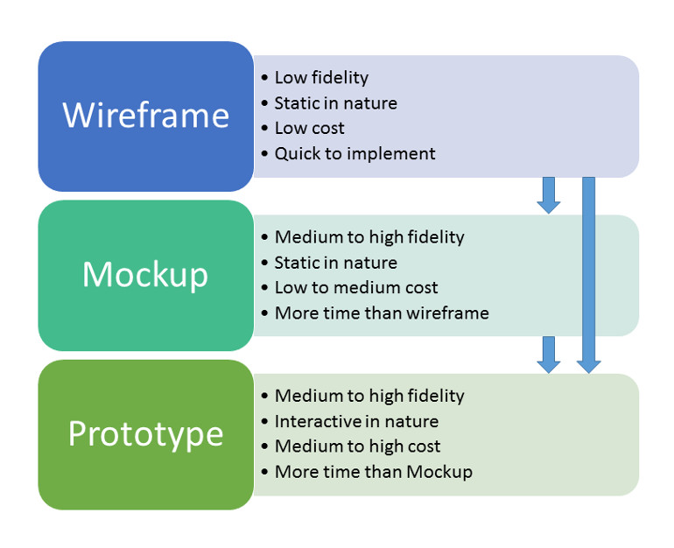

**Roll no 3 -**

She gave me a situation

**You have a client that wants to make a tourist website how will you go about this**

I explained all five UX planes

first is Strategy right? so i said that we will find out user's needs and the purpose of the website

She asked me how will you do that

**At each step she expects you to answer based on the situation**

So like she asked me after i explained Scope layer and how its where functional and content requirements are decided...She asked me what will be those requirements for a tourist website

Roll no 4:

nosql databases ke bare me pucha thoda

NoSQL databases (aka "not only SQL") are non tabular, and store data differently than relational tables. NoSQL databases come in a variety of types based on their data model. The main types are document, key-value, wide-column, and graph. They provide flexible schemas and scale easily with large amounts of data and high user loads.

MongoDB is a cross-platform, document-oriented database that provides, high performance, high availability, and easy scalability. MongoDB works on concept of collection and document.

Prototyping and wireframing ka diff

Can we navigate in prototypes. Yes

**Roll no 5:**

Which tool did u use for prototype design? Wireframe, AdobeXD

Did u use any tool other than that tool? Wireframe

Tell me one striking feature of that tool?

##### 3D Transforms

Rotate objects in 3D space. Present in perspective. Layer in depth and create a realistic outlook in seconds.

##### Auto Height Text

Use the text layer’s content to automatically adjust the height, while its width remains fixed.

##### Nested Components

Make changes to components within other components and seamlessly sync changes only in the context you need.

##### Multiple Flows

Author multiple prototype or interaction flows in a single XD document and publish unique shareable links for each flow.

##### Folders for Cloud Documents

Create folders to organise your Cloud Documents for different projects and clients.

##### Scroll Groups

Create activity feeds, image carousels, product listings and more by defining areas that scroll independently from the rest of your designs. Groups can scroll vertically, horizontally or both.

Did you use any different language (apart from English) in the prototype? No

Did that tool generate code for that UI? No

What are the five different planes of UIUX design ?

Which plane does prototyping come under?

Difference between skeleton and structure?

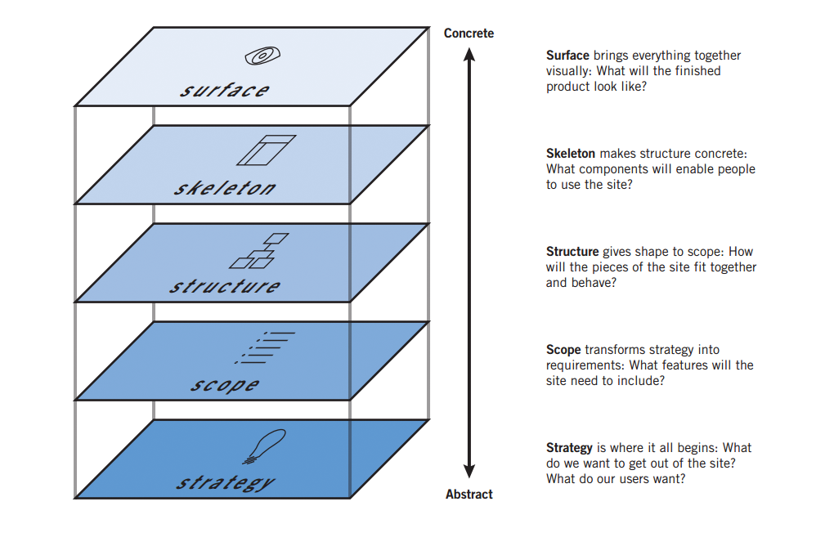

**Roll No 6 -**

She asked me if I have worked with Angular or React. I said Angular. So she asked what are the features of Angular

### **Cross-Platform**

With [Angular](https://www.clariontech.com/blog/angular-framework-from-its-first-steps-to-adulthood), you can develop progressive web applications (PWA). PWA offers an app-like experience to the audience using modern web capabilities.  As per your needs, you can deploy an app as native as well as progressive. The hybrid mobile SDK called Ionic can ship your apps to the app store and deploy the same to the mobile web as PWA.

In addition, you can develop apps for the desktop with Angular

### **High Speed & Optimum Performance**

Angular redefines the modern JavaScript virtual machine by turning templates into code. Thus, your hand-written code can leverage on a productive framework. The best thing about Angular is that you can render the code into HTML & CSS and have the first view of the application on any other platform like NodeJS, .Net, PHP, etc.

The loading time of Angular apps is faster than any other front end framework in the industry. It loads in the speed of Cheetah with any new component router. Further, the code gets split automatically as per user’s loading and rendering requirements.

### **Angular Applications for Everyone**

[Angular](https://www.clariontech.com/blog/angular-vs-react-the-right-pick-for-you-next-project)is a magical front end platform that not only allows developing mind-blowing applications, but also enables to create high-end animations to enhance the user experience. The API of Angular is so intuitive that developers can brew complex choreographic as well as animation with low code.

In addition, with smart unit testing frameworks like Jasmine and Karma, you can fix your broken code anytime. Angular has more than 11 build-in testing modules to ensure error-free code.

Building accessible applications are one of the breakthrough capabilities of Angular. Everyone including people with special abilities can use the accessible applications.

## Angular Technical Features

### **MVC Architecture**

[MVC](https://www.clariontech.com/blog/mvc-vs-flux-vs-redux-the-real-differences) stands for Model-View-Controller. The application data is managed by the Model and View manages the data display. While the controller plays as a connector between the view and model layers. Generally, in MVC architecture, you can split up the app accordingly and write code to connect the same. However, in Angular; developers just need to split up the application into MVC and it does the rest on its own. And it saves a significant amount of coding time.

### **Efficient Two-Way Data Binding**

The most effective Angular feature is its two-way data binding system. The View layer exactly represents the Model layer and they stay in perfect synchronization. If you make any change in the model, the users can see in the view model automatically. Thus, it decreases important development time.

### **Less Code Framework**

Angular is a [low code](https://www.clariontech.com/blog/how-low-code-development-helps-small-businesses) framework comparing to the other front end technologies. You don’t need to write separate code to link the MVC layers. And you don’t require specific code to view manually also. In addition, the directives are isolated from the app code. These all together automatically minimize the development time.

### **Angular CLI (Command Line Interface)**

The Angular CLI follows the industry-best-practices for frontend development with striking build-in features SCSS support or routing. Moreover, the common Angular CLI like ng-new or ng-add supports the developers to discover ready-made features with ease. The basic CLI of Angular is:

What is MVC architecture ?

**M**odel **V**iew **C**ontroller or **MVC** as it is popularly called, is a software design pattern for developing web applications. A Model View Controller pattern is made up of the following three parts −

* **Model** − The lowest level of the pattern which is responsible for maintaining data.
* **View** − This is responsible for displaying all or a portion of the data to the user.
* **Controller** − Software Code that controls the interactions between the Model and View.

MVC is popular as it isolates the application logic from the user interface layer and supports separation of concerns. Here the Controller receives all requests for the application and then works with the Model to prepare any data needed by the View. The View then uses the data prepared by the Controller to generate a final presentable response. The MVC abstraction can be graphically represented as follows.

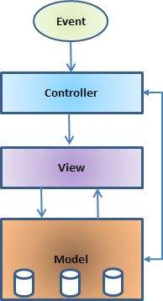

## The Model

The model is responsible for managing the data of the application. It responds to the request from the view and it also responds to instructions from the controller to update itself.

## The View

It means presentation of data in a particular format, triggered by a controller's decision to present the data. They are script-based templating systems like JSP, ASP, PHP and very easy to integrate with AJAX technology.

## The Controller

The controller is responsible for responding to the user input and perform interactions on the data model objects. The controller receives the input, it validates the input and then performs the business operation that modifies the state of the data model.

Importance of functionality and content in Scope plane

What is the need of a storyboard ?

The **storyboard** is a very important part of the pre-production process because it clearly conveys how the story will flow, as you can see how your shots work together. It also allows you to see potential problems that would not go unnoticed, ultimately saving you time and money

**Roll no 7:**

She gave me a website link and asked me to analyse the UI

Next she asked me about the most abstract plane out of the 5 planes ->answer is Strategy

**Roll no 8:-**

Which NoSQL dbs have you worked with?

 NoSQL databases are used in real-time web applications and big data and their use are increasing over time. NoSQL systems are also sometimes called Not only SQL to emphasize the fact that they may support SQL-like query languages.

A NoSQL database includes simplicity of design, simpler horizontal scaling to clusters of machines and finer control over availability. The data structures used by NoSQL databases are different from those used by default in relational databases which makes some operations faster in NoSQL. The suitability of a given NoSQL database depends on the problem it should solve. Data structures used by NoSQL databases are sometimes also viewed as more flexible than relational database tables.

Many NoSQL stores compromise consistency in favor of availability, speed and partition tolerance. Barriers to the greater adoption of NoSQL stores include the use of low-level query languages, lack of standardized interfaces, and huge previous investments in existing relational databases. Most NoSQL stores lack true ACID(Atomicity, Consistency, Isolation, Durability) transactions but a few databases, such as MarkLogic, Aerospike, FairCom c-treeACE, Google Spanner (though technically a NewSQL database), Symas LMDB, and OrientDB have made them central to their designs.

Most NoSQL databases offer a concept of eventual consistency in which database changes are propagated to all nodes so queries for data might not return updated data immediately or might result in reading data that is not accurate which is a problem known as stale reads. Also some NoSQL systems may exhibit lost writes and other forms of data loss. Some NoSQL systems provide concepts such as write-ahead logging to avoid data loss. For distributed transaction processing across multiple databases, data consistency is an even bigger challenge. This is difficult for both NoSQL and relational databases. Even current relational databases do not allow referential integrity constraints to span databases. There are few systems that maintain both X/Open XA standards and ACID transactions for distributed transaction processing.

**Advantages of NoSQL:**  
There are many advantages of working with NoSQL databases such as MongoDB and Cassandra. The main advantages are high scalability and high availability.

1. **High scalability –**  
   NoSQL database use sharding for horizontal scaling. Partitioning of data and placing it on multiple machines in such a way that the order of the data is preserved is sharding. Vertical scaling means adding more resources to the existing machine whereas horizontal scaling means adding more machines to handle the data. Vertical scaling is not that easy to implement but horizontal scaling is easy to implement. Examples of horizontal scaling databases are MongoDB, Cassandra etc. NoSQL can handle huge amount of data because of scalability, as the data grows NoSQL scale itself to handle that data in efficient manner.
2. **High availability –**  
   Auto replication feature in NoSQL databases makes it highly available because in case of any failure data replicates itself to the previous consistent state.

How is Mongo db different from SQL?

MySQL is a relational database management system (RDBMS) from the Oracle Corporation. Like other relational systems, MySQL stores data in tables and uses structured query language (SQL) for database access. When MySQL developers need to access data in an application, they merge data from multiple tables together in a process called a join. In MySQL, you predefine your database schema and set up rules to govern the relationships between fields in your tables.

MongoDB is a [NoSQL database](https://www.mongodb.com/nosql-explained) that stores data as JSON-like documents. Documents store related information together and use the MongoDB query language (MQL) for access. Fields can vary from document to document - there is no need to declare the structure of documents to the system, as documents are self-describing. Optionally, schema validation can be used to enforce data governance controls over each collection.

Difference between wireframe and prototype

[A wireframe is a basic, low-fidelity representation](https://careerfoundry.com/en/blog/ux-design/what-is-a-wireframe-guide/) of the initial product concept, containing the essential elements that would feature on a webpage or app. Wireframes provide a clear outline of the page structure, layout, [information architecture](https://careerfoundry.com/en/blog/ux-design/a-beginners-guide-to-information-architecture/), and overall direction. A wireframe traditionally only uses black, white and grey, and can either be drawn by hand or created digitally.

As wireframes turn abstract ideas into tangible concepts, they’re most relevant in the initial stages of the product design process. Rather than focusing on the product’s look and feel, the main purpose of a wireframe is problem-solving. Conducting user testing during the wireframing phase is incredibly useful for the designer, as it means they can harbor honest feedback that helps to establish the product concept. Often, when a product seems too polished, the user has a heightened sense of awareness surrounding the effort and resources that have played into its creation, making them less likely to provide honest feedback. Without the distractions of color and typography, wireframes facilitate reliable and open input from the user.

In digital wireframes, for example, some designers will use Lorem Ipsum, a pseudo-Latin text that acts as a placeholder for future content. They’ll then prompt the users with questions like “what would you expect would be written here?” For paper wireframes, questions like “what would you expect to happen if you clicked on this button?” are equally enlightening. Questions like these mean the designer can iterate based on what feels intuitive for the user, rather than what feels intuitive for them.

P

As the next step in the product design process after wireframing, a prototype is a working model of an app or a webpage. Prototyping allows designers to test [the user journey](https://careerfoundry.com/en/blog/ux-design/user-flows-vs-wireframes/), reflect on how the user might move between different actions or tasks to achieve certain outcomes, and pinpoint any potential issues with interaction flow.

Similar to a wireframe, a[prototype can be low-fidelity or high-fidelity](https://careerfoundry.com/en/blog/ux-design/design-thinking-stage-four-prototyping/). Elementary in their design, low-fidelity prototypes can either be static paper sketches, or digital drawings or webpages that are interactive and clickable. Low-fidelity prototypes are vital for generating user feedback, as they allow the user to test the interaction flow without a vast expenditure of time or resources.

Wireframe comes under which plane in UX design?

Wireframing work comes under 4th plane, “**Skeleton**”

She asked if I have worked with Angular or React? I said angular

Then she asked me about the  features of Angular.

**Roll no 9:**

What features will you have to increase user interaction?

1. Know your audience
2. Generate relatable and evergreen content
3. Curate advice and feedback
4. Optimize your website
5. Create engaging design
6. Study your analytics design

### **Know your audience**

No matter how innovative the tool used to create your content is, nothing will work if it’s not relevant to your audience.

Therefore, the first step to reaching higher engagement, as simple as it may seem, is getting to know your audience and understanding what is relevant to those you want to attract.

### **2. Invest in usability**

Also, the user needs to feel comfortable inside your pages. This means that they should have a positive [experience](https://en.rockcontent.com/blog/interactive-content-for-customer-experience/) when navigating your website, and that involves usability.

The design and all layout details should be taken into consideration to ensure that visitors can do what they need.

For example, this applies to the [speed of your page](https://en.rockcontent.com/blog/google-pagespeed-insights/). According to a Kissmetrics survey, **40% of users leave a page that takes more than 3 seconds to load**. Each second more can represent a 7% loss in conversions.

### **3. Encourage the user to give feedback**

It can be done through a form or the comments space in a blog post, for example.

The important part is encouraging the user to leave their opinion on what they thought about your content or how their experience was on your website.

You can offer an area on your blog so that the reader leaves a comment after reading the content.

Creating evaluation surveys is also important. They allow you to receive feedback on what can be improved, and the user feels that their opinion is relevant. This helps them to start trusting your company even more.

### **4. Focus on interactive content**

To impact your [buyer persona](https://en.rockcontent.com/blog/buyer-persona/), nothing better than employing [interactive content](https://en.rockcontent.com/blog/what-is-interactive-content/) in your blog.

According to your research, you can choose the formats that best fit your audience’s preferences. The goal is that the visitor feels instigated to interact with your content.

And the good news: there are many possibilities, like [calculators](https://en.rockcontent.com/blog/interactive-calculator), [infographics](https://en.rockcontent.com/blog/interactive-infographic/), and even [quizzes](https://en.rockcontent.com/blog/interactive-quiz/). **The idea is that the feature offered is useful for the user.**

A calculator that shows how much they can save by investing in [SEO](https://en.rockcontent.com/blog/what-is-seo/) is an example. Or even an infographic that allows the customization of the data that will appear.

Interactive content also brings a bonus: it generates data about your audience, which can be used to enhance your content strategy.

### **5. Offer live experiences**

Another way to ensure interaction with your audience is by offering [live experiences](https://en.rockcontent.com/blog/live-experience/). With updates in real-time, the user is invited to be part of that content.

An example is [live blogging](https://en.rockcontent.com/blog/live-blogging/), which allows **a constant updating of the same page to present everything new in an event**.

[Live streaming](https://en.rockcontent.com/blog/live-streaming/) can also be an attractive option. The format allows you to answer visitors’ questions, which increases interaction with the audience and makes them feel valued.

How will you design a registration form with personal info, edu info and extra curricular info?

If there are names, DOB, city and address fields in person how will you design this form?

**Roll no 20:**

Explain the 5 planes

Wireframing vs prototype

Which databases have you worked with?

**Roll no 21:**

Did u use firebase

Kaise db set up krte hai usme

Node js use kiya hai kya

React ke features batao

### **JSX**

JSX stands for JavaScript XML. It is a JavaScript syntax extension. Its an XML or HTML like syntax used by ReactJS. This syntax is processed into JavaScript calls of React Framework. It extends the ES6 so that HTML like text can co-exist with JavaScript react code. It is not necessary to use JSX, but it is recommended to use in ReactJS.

### **Components**

ReactJS is all about components. ReactJS application is made up of multiple components, and each component has its own logic and controls. These components can be reusable which help you to maintain the code when working on larger scale projects.

### **One-way Data Binding**

ReactJS is designed in such a manner that follows unidirectional data flow or one-way data binding. The benefits of one-way data binding give you better control throughout the application. If the data flow is in another direction, then it requires additional features. It is because components are supposed to be immutable and the data within them cannot be changed. Flux is a pattern that helps to keep your data unidirectional. This makes the application more flexible that leads to increase efficiency.

### **Virtual DOM**

A virtual DOM object is a representation of the original DOM object. It works like a one-way data binding. Whenever any modifications happen in the web application, the entire UI is re-rendered in virtual DOM representation. Then it checks the difference between the previous DOM representation and new DOM. Once it has done, the real DOM will update only the things that have actually changed. This makes the application faster, and there is no wastage of memory.

### **Simplicity**

ReactJS uses JSX file which makes the application simple and to code as well as understand. We know that ReactJS is a component-based approach which makes the code reusable as your need. This makes it simple to use and learn.

### **Performance**

ReactJS is known to be a great performer. This feature makes it much better than other frameworks out there today. The reason behind this is that it manages a virtual DOM. The DOM is a cross-platform and programming API which deals with HTML, XML or XHTML. The DOM exists entirely in memory. Due to this, when we create a component, we did not write directly to the DOM. Instead, we are writing virtual components that will turn into the DOM leading to smoother and faster performance.

Ux ke liye kya use kiya

Usme kya acha laga

What are wireframes?

Difference between wireframes and prototype

Diff bet structure and skeleton

**Roll no 23:**

What is user experience?

Have you worked on django?No

Why is nosql better than sql?

### s NoSQL faster than SQL?

In general, NoSQL is not faster than SQL just as SQL is not faster than NoSQL. For those that didn’t get that statement, it means that speed as a factor for SQL and NoSQL databases depends on the context.

SQL databases are normalized databases where the data is broken down into various logical tables to avoid data redundancy and data duplication. In this scenario, SQL databases are faster than their NoSQL counterparts for joins, queries, updates, etc.

On the other hand, NoSQL databases are specifically designed for unstructured data which can be document-oriented, column-oriented, graph-based, etc. In this case, a particular data entity is stored together and not partitioned. So performing read or write operations on a single data entity is faster for NoSQL databases as compared to SQL databases.

### Is NoSQL better for Big Data Applications?

They say “Necessity is the Mother of Invention!” and that certainly turned out to be true in the case of NoSQL. The NoSQL databases for big data were specifically developed by the top internet companies such as Google, Yahoo, Amazon, etc. as the existing relational databases were not able to cope with the increasing data processing requirements.

NoSQL databases have a dynamic schema that is much better suited for big data as flexibility is an important requirement. Also, large amounts of analytical data can be stored in NoSQL databases for predictive analysis. An example of this is data from various social media sites such as Instagram, Twitter, Facebook, etc. NoSQL databases are horizontally scalable and can ultimately become larger and more powerful if required. All of this makes NoSQL databases the preferred choice for big data applications.

What are wireframes?

Are wireframes always required or can you build it without a wireframe?

**Roll No 26**:

Which app did you make?

What features of UI you took into consideration?

How did you test the app?

How did you make the prototype?

**Roll No 30**:

Crud fullform

Why is Mongodb called no sql database

Why prefer mongodb

The **NoSQL database** is a way of storing **data** in means other than the relational **database**. The **NoSQL** varieties are further categorized into key-value, column, graph, and document, to **name** a few. **MongoDB** is an open source software that falls under the "Document" category.

MongoDB enables horizontal scalability by using a technique called sharding. Sharding distributes the data across physical partitions to overcome the hardware limitations. The data is automatically balanced in the clusters.

It also provides ACID properties at the document level as in the case of relational databases.

It supports replica sets; in other words, a failover mechanism is automatically handled. If the primary server goes down, the secondary server becomes the primary automatically, without any human intervention.

It supports the common authentication mechanisms, such as LDAP, AD, and certificates. Users can connect to MongoDB over SSL and the data can be encrypted.

MongoDB can be a cost effective solution because improves flexibility and reduces cost on hardware and storage.

Which open source u used for prototype and why

Strategy and scope explain b